21.57: An infinite line of charge has a radial field in the plane through the wire, and constant in the plane of the wire, mirror-imaged about the wire:

Cross section through the wire: Plane of the wire:

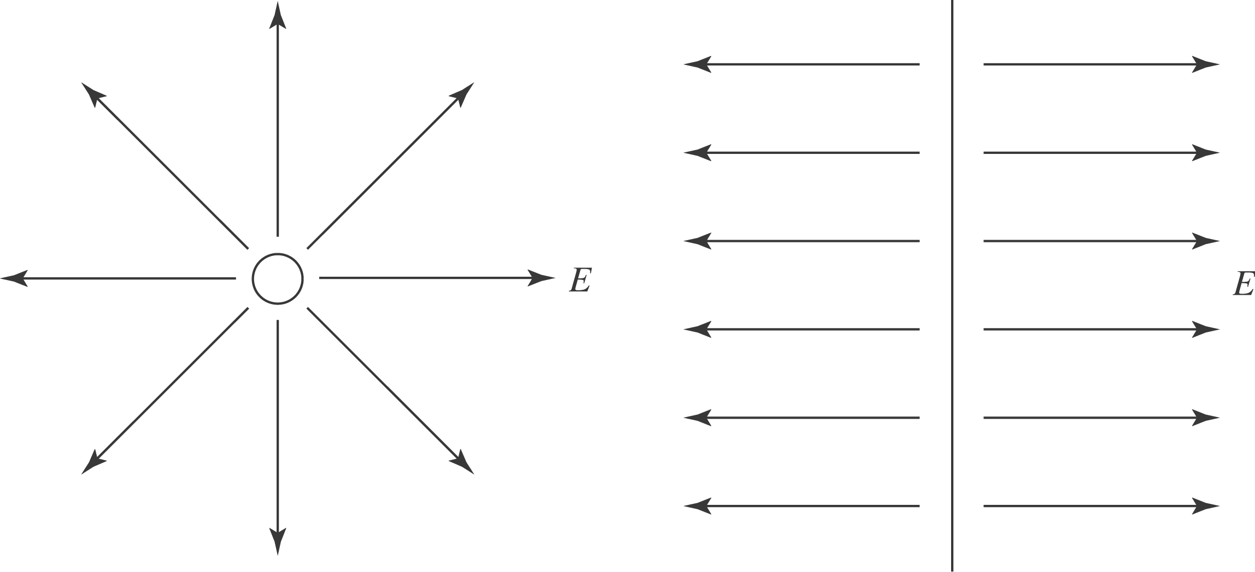

Length of vector does not depend on angle. Length of vector gets shorter at points further away from wire.

